**Transforming Care**

**Children and Young People’s Self-Referral Pathway**

A pathway for children or young people aged under 18 years of age with autism and/or learning disabilities who may be at risk of a specialist mental health hospital admission, or different living arrangements due to unsafe behaviours.

If there is an immediate risk to safety:

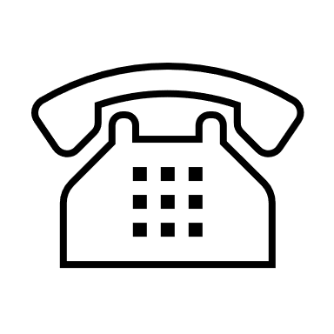Contact the ‘all age’ 24/7 Mental Health Crisis Line on NHS 111 option 2 in the first instance, before attending A&E.

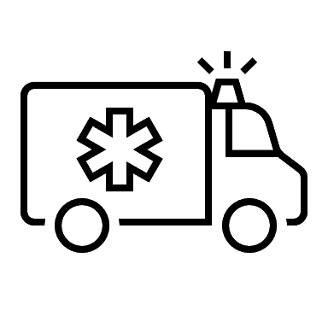If urgent medical attention is required, please call 999 or attend A&E as appropriate where CAMHS Crisis Team can assess.

`

**Outcome**

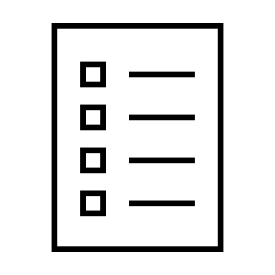

BLMK ICB will contact you to tell you the outcome:

Referral accepted and child/young person is added to their local Dynamic Support Register and next steps will be advised.

**Or**

BLMK ICB will request further information and update you on next steps.

**Or**

Signposting to the appropriate services and support if your referral is not accepted. You can self-refer again, at any time, if your situation changes

`**Review**



Your referral will then be reviewed within 7 days by BLMK ICB.

.

**Referral**

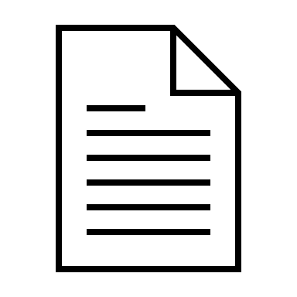

You can complete the referral form yourself (If you would like help to complete the form, please ask your CAMHS Practitioner, your Social Worker, or your School Teacher).

**Or**

You can contact your lead practitioner in CAMHS, Social Care or School who can complete the referral with your consent.

**It is important that your form is completed with as much information as possible.**

`

`**Email your form**



When you have completed your form, please email it to Bedfordshire Luton and Milton Keynes Integrated Care Board (BLMK ICB): [**blmkicb.cyptcp@nhs.net**](mailto:blmkicb.cyptcp@nhs.net)

* I am a young person who has Autism and/or Learning Disabilities. I am worried I might need to be admitted to a mental health hospital.

and/or

* I am a young person who has Autism and/or Learning Disabilities. I am worried my behaviour is not safe at home.

**Concerns**



* I am a parent of a child/young person who has Autism and/or Learning Disabilities and they are at risk of mental health hospital admission.

and/or

* I am a parent of a child/young person who has Autism and/or Learning Disabilities with behaviour that may no longer be safely supported within the family home.